Meeting Agenda
Virtual, Microsoft Teams Click here to join the meeting
5th July 2021 10.00am
Agenda
 | Timings
1. Welcome and Introductions | 10.00am
2. Urgent items of business | 10.05am
3. Minutes of the meeting on 8 February 2021 and matters arising not on the agenda  SUMMARY OF AGREED ACTIONS –  Item Action  4 Lewis Williams to collate information on climate change and add it to ESSP website Completed  5 Lewis Williams to discuss the IVAR report with Steve Manwaring Completed  6 Lewis Williams to add wellbeing information to the ESSP website Completed | 10.10am
4. Introduction – Gordon Ackroyd  Gordon Ackroyd the CEO of Action in Rural Sussex will introduce himself and outline the challenges facing rural communities in the county  Please find a bio of Gordon below for information | 10.15am
5. Overview of East Sussex – Becky Shaw  Presentation and discussion | 10.20am
6. Youth Cabinet Annual Report – Atiya Gourlay  Presentation and discussion | 11.00am
7. Institute for Voluntary Action Research report – Steve Manwaring  Presentation and discussion | 11.25am
8. Election of ESSP Chair | 11.50am
9. Any other business | 11.55am
10. Dates of future meetings: Please note in your diaries
Friday 26th November 2021 – East Sussex Assembly TBC
Close of meeting | 12.00pm
Venue: Virtual

Gordon Ackroyd Bio:
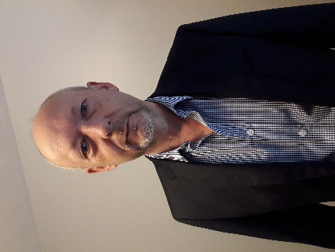
Gordon Ackroyd became the new CEO of Action in Rural Sussex at the start of 2021.
His mission is to make the 80-year-old organisation relevant to the rural community in the 21st century and build a new business model to sustain it - hopefully for the next 80 years.
Beginning a long career first in corporate video and conference production, he went on to found one of the first advertising agencies specialising in the NGO and environmental campaigning sectors.
Later, with more than a dozen non-exec directorships and third-sector governance positions to his credit, Gordon moved into training for social enterprise, and mentoring start-ups and growth businesses – work which led him and his family to life in the Falkland Islands, where he supported private-sector enterprise in developing the rural economy.
Gordon is an enthusiast for partnership working and effective linkages between the public, private and VCSE sectors – especially where these partnerships are equal, transparent, efficient and results-driven. His drive is to see Action in Sussex deliver work with greater value for money and lasting impact.
After five years on the Falkland’s, his greatest pleasure in Sussex is “looking at trees”.

