

**East Sussex Assembly Annual Conference**

Monday 23 November 2020, virtually via [Microsoft Teams](https://teams.microsoft.com/l/meetup-join/19%3ameeting_NzRmMGFhOWUtOWY4OC00MTQ3LWFjMjgtZGY1Yjc0ZWM4NDlm%40thread.v2/0?context=%7b%22Tid%22%3a%22e26de7e3-b799-4df6-aa7d-16758c76b331%22%2c%22Oid%22%3a%22ab898002-0b84-43ac-9a40-4be5a396e938%22%7d)

**Main theme:** Climate change: how can we all adapt to meet the challenges of a changing environment

**\*Programme subject to change\***

|  |  |
| --- | --- |
| **9.00am** | **Log on** [**here**](https://teams.microsoft.com/l/meetup-join/19%3ameeting_NzRmMGFhOWUtOWY4OC00MTQ3LWFjMjgtZGY1Yjc0ZWM4NDlm%40thread.v2/0?context=%7b%22Tid%22%3a%22e26de7e3-b799-4df6-aa7d-16758c76b331%22%2c%22Oid%22%3a%22ab898002-0b84-43ac-9a40-4be5a396e938%22%7d) |
| **9.05am** | **Welcome and introduction**  Dawn Whittaker (East Sussex Strategic Partnership Chair)  The climate change challenges facing East Sussex? |
| **9.30am**  **10.00am**  **10.10am**  **10.40am**  **10.50am**  **11.00am**  **11:30am**  **11:40am** | **Breakout session 1**  **Back into main room – group 1 provides three main talking points from their session**  **Breakout session 2**  **Back into main room – group 2 provides three main talking points from their session**  **Comfort break**  **Breakout session 3**  **Back into main room – group 3 provides three main talking points from their session**  **Conclusion and thanks – Dawn Whittaker (Chair)** |

**ABOUT THE EVENT**

Climate change presents some of the most significant challenges, threats, but also opportunities facing East Sussex over the coming years. The Assembly will explore how various organisations and groups can adapt to help the county reduce its carbon footprint and meet future challenges.

**ABOUT ESSP**

East Sussex Strategic Partnership (ESSP) brings organisations together to plan local services and tackle the issues that matter to local people. Our main tasks are to:

* develop and deliver the Sustainable Community Strategy for East Sussex, [Pride of Place,](https://www.essp.org.uk/what-we-do/pride-of-place/) a long-term plan for improving quality of life for those living and working in East Sussex
* deliver other action plans, which aim to tackle the priorities set out in Pride of Place
* report on [our progress and performance](https://www.essp.org.uk/what-we-do/our-progress/) to local partners and the general public
* provide leadership on countywide issues where no other appropriate organisation or partnership can be identified.

**ABOUT THE EAST SUSSEX ASSEMBLY**

The [Assembly](https://www.essp.org.uk/about-us/our-wider-partners/east-sussex-assembly/) is the ESSP's consultative and advisory forum, and one of the largest cross-sector networks in the county. It comprises almost 100 organisations and partnerships from the public, private and voluntary and community sectors that are involved or interested in public services and improving life in East Sussex.

**FORMAT**

Due to COVID-19 restrictions the meeting is being held virtually via Microsoft Teams, delegates can access the meeting by clicking [here](https://teams.microsoft.com/l/meetup-join/19%3ameeting_NzRmMGFhOWUtOWY4OC00MTQ3LWFjMjgtZGY1Yjc0ZWM4NDlm%40thread.v2/0?context=%7b%22Tid%22%3a%22e26de7e3-b799-4df6-aa7d-16758c76b331%22%2c%22Oid%22%3a%22ab898002-0b84-43ac-9a40-4be5a396e938%22%7d)

**CONTACT:** For all enquiries: Lewis Williams [essp@eastsussex.gov.uk](mailto:essp@eastsussex.gov.uk)

**PROTOCOLS:**

**Main room:**

* All delegates should mute their microphone when in the main room, using this icon 
* Delegates may potentially need to turn off their cameras to help with the bandwidth capacity, this can be done using this icon 
* If delegates need to ask a question or have something to say they should ‘raise their hand’ using this icon 
* The Chair won’t be able to field questions in the chat, so any questions put into the chat field will be raised with the chair by the administrator if possible, or addressed after the meeting if necessary. The chat can be accessed using this icon 

**Breakout rooms:**

* The breakout rooms will involve a presentation format followed by an open discussion
* Delegates should have their microphones muted during the presentation
* Delegates should ‘raise their hand’ if they want to join the discussion
* The presenter probably won’t be able to deal with questions in the chat as well as facilitating the discussion and presenting, so if possible, all questions should be verbal

**SPEAKERS:**

**Anya Ledwith, ESHCON:**



Anya Ledwith is an award-winning consultant. Through ISO 14001 Environmental Management Systems (EMS), SECR carbon reporting, Net Zero and ESOS energy audits, Anya helps fast growth and corporates reduce impacts, cut costs, save time and win business: This is Effective Environmental Management.

**Zoë Osmond, Clean Growth UK:**

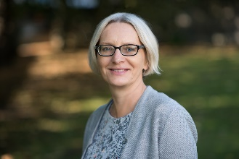

An MBA and Development Studies degree holder, Zoë has over 15 years’ experience of developing business opportunities and facilitating innovation in low carbon and environmental sectors.

**Michael Turner, Environment Agency:**

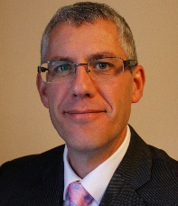

Even after the coronavirus pandemic has subsided, we’ll still need to be responding to the climate emergency. The Environment Agency has set its ambition to become a ‘net zero’ organisation by 2030. My session at the East Sussex Assembly will set out our pathway to achieving this. The teams I manage in East Sussex do great work protecting communities and the environment from flooding and pollution but produce too much carbon. My role is the same as everyone’s – to be a climate ambassador – reducing and eventually eliminating my footprint and help those who I work with do the same.

I have always been interested in the world outside, from studying Astronomy GCSE to monitoring shrinking glaciers in the Arctic to becoming a Chartered Environmentalist. I am delighted to have made East Sussex my home and enjoy trail running and cycling within its treasured landscapes.

**Andy Arnold, East Sussex County Council:**

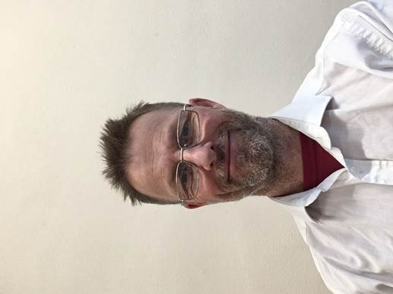

I manage the Environment Team at the county council, which covers air quality, noise, climate change, ecology, landscape, archaeology and tree diseases. Our core job is providing specialist environmental advice to a number of local planning authorities. We also host various partnerships, including the Sussex Air Quality Partnership and the Sussex Local Nature Partnership, and deliver a range of environmental projects. I previously worked in the waste industry for a number of years and before that for Friends of the Earth. My passion for the environment began properly when Chico Mendes, a rubber planter in the Amazon, was murdered by a rancher in 1988, which brought home to me that the ‘environment’ covers so many fundamental and inter-related aspects: values, conflict, inequality and so on, as well as simply our physical environment. This makes the environment field fascinating and ever-changing.

**The Youth Cabinet:**

Due to it being a school day, members of the Youth Cabinet aren’t able to attend the meeting, but they’ve provided an online video detailing their focus on climate change which can be found [here](https://www.youtube.com/watch?v=z6Js0R6c4RM).