Agenda Item 6c

Report to: | East Sussex Strategic Partnership (ESSP)
Date: | 19 April 2012
Title: | Water Framework Directive delivery in the Adur & Ouse catchment
Author: | Chris Wick, Environment Manager, Environment Agency
Purpose: | For information

Recommendation:
- East Sussex Strategic Partnership support the work being co-ordinated by the Adur & Ouse Partnership to deliver the East Sussex Environment Strategy, Water Framework Directive objectives, and reduce flood risk.
- Partners consider whether their organisation should be involved and contact Catherine Fuller at the Environment Agency if they wish to participate

- Introduction/Background
  - The Water Framework Directive
The European Water Framework Directive enables us to make our local environment better for people and wildlife. The Directive came into force in December 2000 and became part of UK law in December 2003.
The Directive will help to protect and enhance the quality of:
- surface freshwater (including lakes, streams and rivers)
- groundwaters
- groundwater dependant ecosystems
- estuaries
- coastal waters out to one mile from low-water.

The rivers of England and Wales have been split up into individual ‘waterbodies’, which together form ‘river basin districts’. There are 11 river basin districts. The South East River Basin District includes Hampshire, the Isle of Wight, West Sussex, East Sussex, and the coastal area of Kent (figure 1).

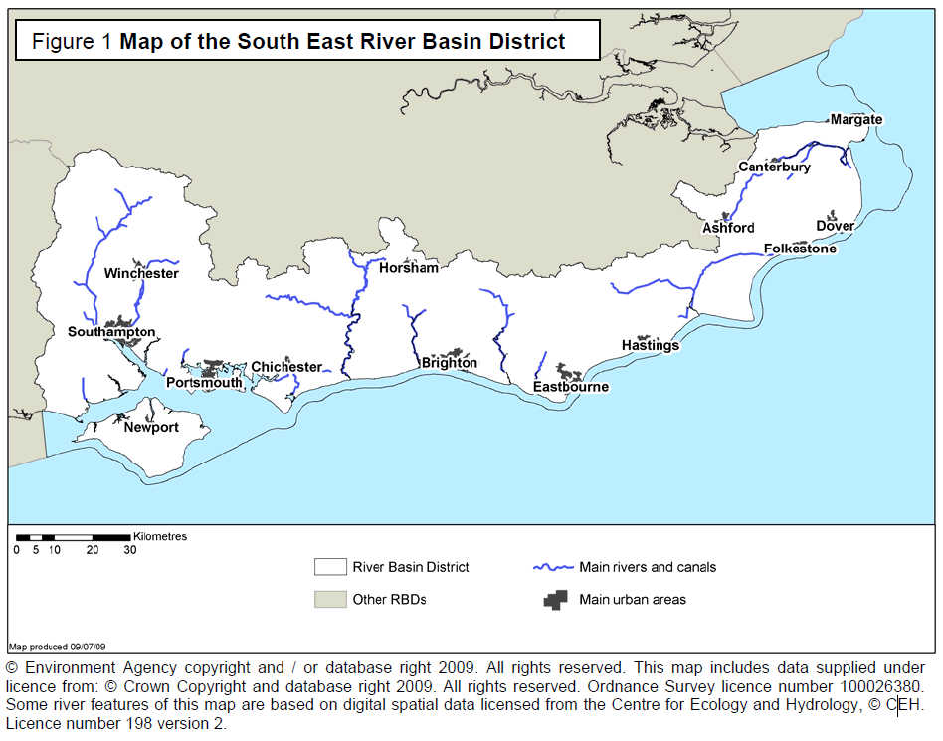

  - River Basin Management
River basin management is the approach the Environment Agency is using to ensure our combined efforts achieve the improvement needed in the South East River Basin District. River basin management is a continuous process of planning and delivery. The Water Framework Directive introduces a formal series of 6 year cycles. The first cycle will end in 2015 when, following further planning and consultation, this plan will be updated and reissued.

The South East River Basin Management Plan (RBMP) has been prepared under the Water Framework Directive, which requires all countries throughout the European Union to manage the water environment to consistent standards. Each country has to:

- prevent deterioration in the status of aquatic ecosystems, protect them and improve the ecological condition of waters;
- aim to achieve at least good status for all water bodies by 2015. Where this is not possible and subject to the criteria set out in the Directive, aim to achieve good status by 2021 or 2027;
- meet the requirements of Water Framework Directive protected areas;
- promote sustainable use of water as a natural resource;
- conserve habitats and species that depend directly on water;
- progressively reduce or phase out the release of individual pollutants or groups of pollutants that present a significant threat to the aquatic environment;
- progressively reduce the pollution of groundwater and prevent or limit the entry of pollutants;
- contribute to mitigating the effects of floods and droughts.

The South East RBMP can be accessed online by visiting http://www.environment-agency.gov.uk/research/planning/124978.aspx. The plan was prepared in consultation with a wide range of organisations and individuals, and describes the district and the pressures that the water environment faces. It shows what this means for the current state of the water environment in the river basin district, and what actions will be taken to address the pressures. It sets out what improvements are possible by 2015 and how the actions will make a difference to the local environment – the catchments, estuaries, the coast and groundwater.

  - The South East River Basin District Liaison Panel
The South East River Basin District Liaison Panel has been central to helping us manage the river basin management process. The panel includes representatives of businesses, planning authorities, environmental organisations, consumers, navigation, fishing and recreation bodies and central, regional and local government, all with key roles to play in implementing this plan. The plan has been prepared with the support and contributions of the panel members, and the sectors that they represent. They have also helped the Environment Agency work with local stakeholders to identify the actions needed to address the main pressures on the water environment.

For more information about the liaison panel, including membership and meeting information, please visit http://www.environment-agency.gov.uk/research/planning/33156.aspx.

  - The catchment approach
Many of the problems facing our water environments are best understood, and tackled, at a catchment level. In March 2011, Defra appointed the Environment Agency to lead on ten catchment pilots across the country. There are also a number of additional Defra catchment pilots which are being led by other organisations, for example the New Forest National Park. Following on from the initial success of these pilots, wider catchment initiatives have been set up also. Appendix 1 shows a map of the 25 Defra pilots, as well as the locations of the wider catchment initiatives.

The initial ten pilot catchments were chosen for their variety (rather than importance), so that any new ways of working can be applied to a wide range of scenarios. All catchments include failing water bodies (under Water Framework Directive standards) and take into account:
- different geographical regions;
- different pressures from pollutants or riverbank modifications;
- bathing water, drinking water and wider environmental problems;
- a range of rural and urban catchments;
- groundwater and surface waters;
- different previous experiences of engagement.

The project covers England only, although Environment Agency Wales is adopting a similar ‘citizen-centred’ approach providing further opportunities to identify what works well.

The focus of the Defra pilots is to explore better ways to engage with people and organisations to help improve the water environment. The aims of the catchment pilots (as set out by Defra) are to:

- Trial different approaches for partner engagement at a local level to secure additional action and greater environmental outcomes. Doing this by bringing local interest groups together and involving them in decision making, sharing information and develop agreed action plans.
- Align our existing activities to support the objectives of the catchment (from monitoring to enforcement) and work closely with our regulatory partners to target their activity.
- Contribute to our Corporate Plan objectives under ‘embedding ways of working’.
- Gather learning from additional catchment pilots that are led by others.

The catchments within the South East River Basin District can be found in Appendix 2.

- The Adur and Ouse pilot catchment
  - Catchment information
The Adur and Ouse catchment is one of the ten Defra catchment pilots. The Adur and Ouse catchment has an area of 980 square kilometres, and is well known for both its urbanised coast and the South Downs National Park. It includes the city of Brighton and Hove and the port areas of Newhaven and Shoreham. Within the catchment, there are 48 surface water bodies, two Sites of Special Scientific Interest (SSSI) ditches, one lake, seven groundwater bodies, two estuaries and one coastal water body.
  - Water Framework Directive status in the Adur and Ouse catchment
There are issues with the quality of effluent from the Goddards Green, Barnes Green and Coolham sewage treatment works, and problems with diffuse pollution from agriculture. Obstruction to fish passage in the River Ouse is a major problem, especially when there are prolonged periods of low river flow, and ecology would benefit from more naturalised river channels in many places. These are key reasons why more waters are not at good status now.

A map showing the status of the Adur and Ouse water bodies can be found in Appendix 3.

  - Delivering improvements
Last year the Environment Agency successfully secured funding from Defra for projects to deliver the Water Framework Directive in the Adur and Ouse catchment. In 2011/2012 we spent approximately £1 million on improving the water environment in the Adur and Ouse. This financial year (2012/2013), we have been awarded a further £1.6 million of Defra funding for the catchment. This represents a real success for Sussex as the total available nationally under this fund is only £9 million a year and there are 100 catchments eligible.

Projects funded in 2011/12 include:
Middle Ouse Restoration of Physical Habitats (MORPH) – discussed in more detail below
Adur Restoration of Physical Habitats Assessment (ARPHA) – a similar project for the river Adur
Restoration of the Teville Stream (in Worthing)
Diffuse Agricultural Pollution projects
Evaluating an ecosystems services approach on the River Ouse with South East Water
Managing Coastal waters with the Sussex Inshore Fisheries and Conservation Authority
Implementation of Eel management plans in the catchment

  - The Adur & Ouse Partnership
The Adur & Ouse Partnership were established in October 2011, with support from a number of organisations. The Partnership is hosted by the Environment Agency as one of ten initial Defra led pilot catchments, but has been developed collaboratively with all interested parties agreeing to commit time and resource. The Partnership exists to:
Improve our local waters in the Adur and Ouse and achieve more ambitious environmental goals by:
- Working together to understand the issues.
- Discussing and agreeing on outcomes and priorities.
- Sharing information and resources.
- Working together to tackle difficult issues that require multi-agency input.
- Working collaboratively to deliver work on the ground to achieve the agreed outcomes.

A core steering group provides direction and co-ordination for work in the Adur and Ouse catchment; this group currently has 12 members who currently meet monthly:

- Brighton and Hove City Council
- Brighton University
- Environment Agency
- Forestry Commission
- Inshore Fisheries and Conservation Authority
- National Trust
- Natural England
- Ouse and Adur Rivers Trust
- South Downs National Park
- South East Water
- Southern Water
- Sussex Wildlife Trust

The Adur & Ouse Steering Group collaboratively developed six work themes and have agreed to form sub-groups (task & finish groups) to pursue each theme. Adur & Ouse task & finish groups will understand the complex issues within the Adur and Ouse catchment by drawing on a wide range of expertise. This understanding will stem from robust evidence gathered from the wider Adur & Ouse Partnership and local communities.
The evidence will be used to underpin all action in the Adur and Ouse catchment and form the basis of the Adur & Ouse Catchment Plan.

The six themes are:
- Coastal waters
- Engagement
- Fisheries
- Groundwater
- Natural Rivers
- Surface water quality

The Partnership will also link up with and support other work streams where possible, for example Nature Improvement Area and Brighton & Hove and Lewes Downs Biosphere Partnership objectives.

Task & finish groups are currently being set up (one for each theme). To get involved with a particular group, please contact the catchment coordinator for the Adur and Ouse: Catherine Fuller 01903 832309 or e-mail Catherine.fuller@environment-agency.gov.uk.
We are utilising a number of communications channels to increase awareness of the Adur & Ouse Partnership. One example is the use of an independent website, www.fishactive.com, to post online information targeted at anglers and people interested in the water environment. This website also hosts the Adur & Ouse blog and also provides a forum for people to feed their views into the Partnership.
Information is updated on our website regularly. Please visit http://www.environment-agency.gov.uk/catchments for the most recent information about the pilot.
  - The MORPH project
    - Introduction to the project
The Middle Ouse Restoration of Physical Habitat (MORPH) project is the largest project in the Adur and Ouse catchment accounting for £600,000 of the £1.6 million Defra funding allocated for 2012/2013.
The project seeks to reduce flood risk and improve fish passage and biodiversity by re-naturalising a number of sections of the river Ouse. It is a joint project between the Environment Agency, the Ouse and Adur Rivers Trust (OART), and the National Trust (at Sheffield Park).
Investigations since the 2000 floods have concluded that flood risk to Uckfield and Lewes can be reduced if the upper reaches of the Ouse are used to store water during times of high water levels. This sustainable method for managing flood risk over the next 50 to 100 years can be achieved by restoring the natural floodplain. Further details are available in the River Ouse Catchment Management Flood Plan (CFMP)

The sites at which we are planning to carry out improvements are shown in Appendix 4. We regularly update our website with new information. Please visit: http://www.environment-agency.gov.uk/research/planning/136633.aspx.

    - Progress so far
Over the past year our consultants have produced detailed designs for three sites, and provided options appraisal for four sites. Where we have detailed designs we will choose a ‘final’ design shortly, with the aim of awarding a contract and starting work this summer.
We held a public drop-in event in December 2011 (figure 5). This event was attended by nearly 70 local people, and feedback found that:
- 90% of attendees understood why we are carrying out the project either ‘quite well’ or ‘very well’
- 91% of attendees thought that restoring the floodplain is the right thing to do.
We have since been having one to one engagement at site specific locations, ensuring that people are truly involved throughout the project.

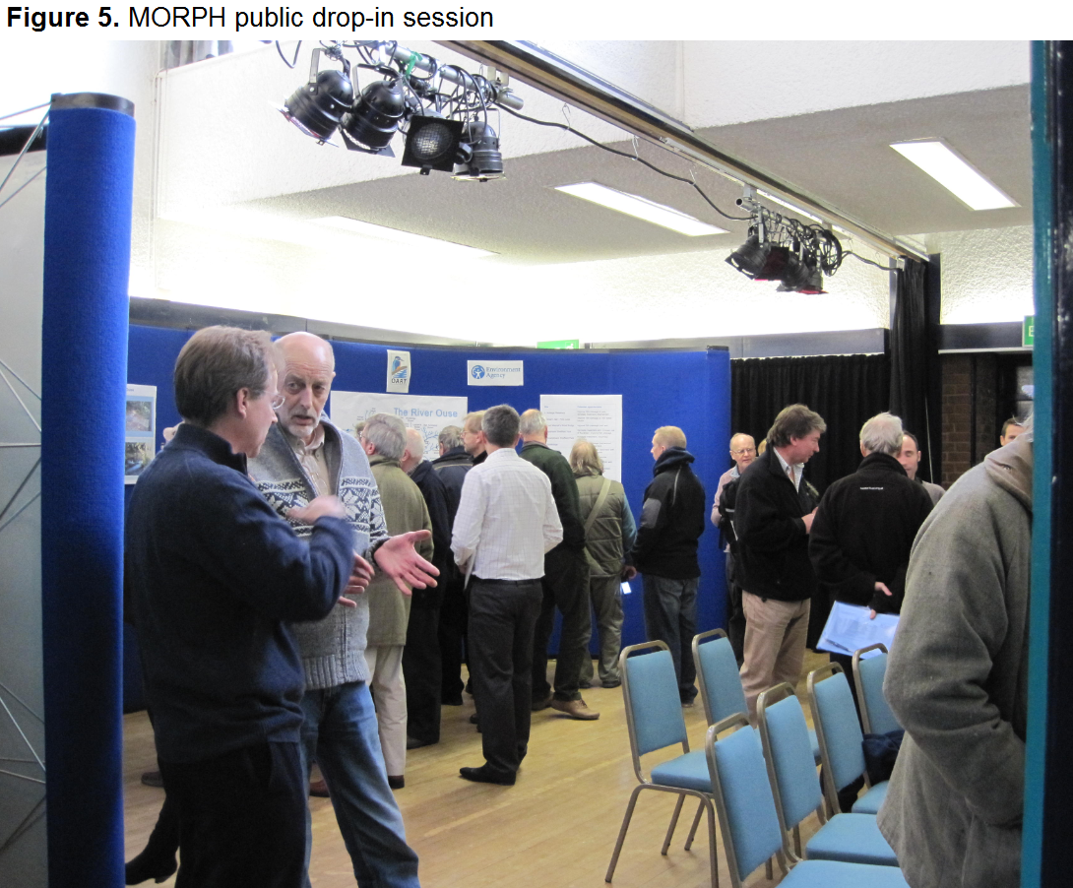

Fletching Weir provides a local example of what might be achieved by re-naturalising sections of the river. As a result of natural deterioration, the weir, which was partially blocking the river, collapsed (figure 3). Our monitoring of the fish population has found that after two years, the number of fish species has increased from 6 (in 2009 before the structure collapsed) to 14 (in 2011 after the structure collapsed).
The habitat at this site is now much more diverse and has plants growing in the channel. The removal of the structure has allowed the river to reform back to its natural state, which has allowed fish to access a new part of the river, as well as providing gravel substrate with the potential for use as spawning habitat (figure 4). This was the first step towards reducing the risk of flooding to property downstream, as during high flows the river can use the natural surrounding floodplain.

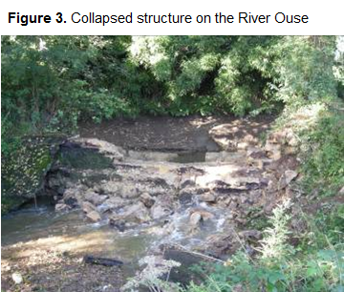
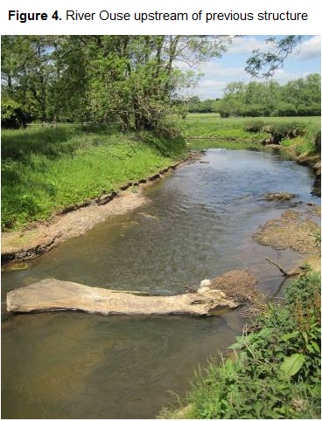
- Links with the Environment Strategy for East Sussex
  - Principle 2 of the Environment Strategy
“Reduce our greenhouse gas emissions, become more adaptive to climate change and help individuals and communities to do the same”

Climate change predictions have indicated a wetter climate in the future. By allowing a river to use natural floodplains in safe upstream locations we are reducing the impact of high water levels to communities downstream. The MORPH project is actively looking to reinstate natural floodplains in the upper catchment, therefore reducing risk downstream ion the towns of Uckfield and Lewes.

  - Principle 3 of the Environment Strategy
“Protect and enhance the diverse inland, coastal and marine habitats of the county and the wildlife they support, making them more resilient to climate change, reversing biodiversity loss, and help create healthy seas and sustainable fisheries”
The work of the Environment Agency directly relates to this principle. The ultimate aim of the Water Framework Directive is to protect and enhance the quality of our water environment. Through our work in the Adur and Ouse pilot catchment we will be increasing diversity of habitats, improving water quality and improving fish passage. The Adur and Ouse catchment also includes the coast and we are working closely with the Sussex Inshore Fisheries and Conservation Authority (IFCA) to understand the pressures facing our coastal environment.
- Concluding comments

The Water Framework Directive is part of UK law and the Environment Agency has a duty to fulfil its objectives. We have identified the Adur and Ouse catchment as a place where we can improve the environment relatively quickly and have secured funding for a number of projects this year.

The Adur & Ouse Partnership is a new collaborative partnership which aims to achieve more ambitious environmental goals by bringing together the work of several organisations and engaging the local community. This way of working is already proving very effective, and we hope to replicate this model across the other catchments in the South East including the Cuckmere and Pevensey Levels catchment in East Sussex.

Partners can get involved by contacting:

Chris Wick – Environment Manager – 01903 703871
Catherine Fuller – Catchment Co-ordinator - 01903 832309

