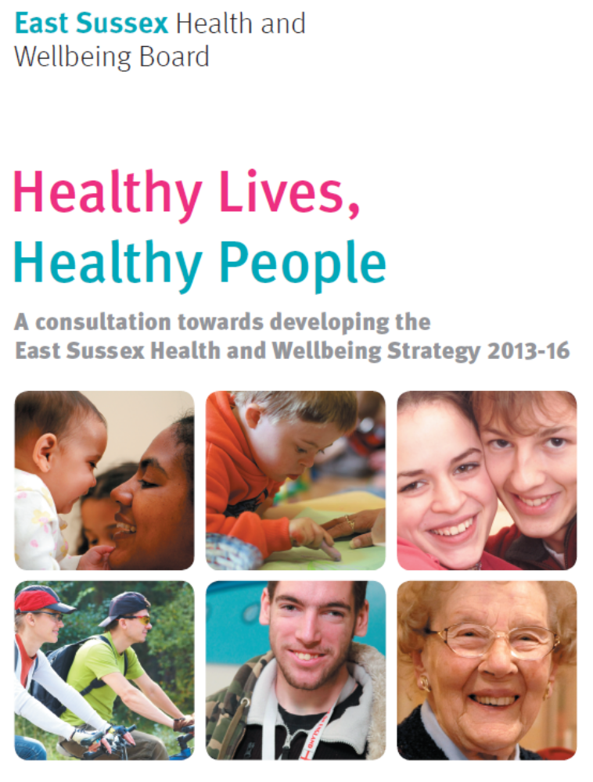

Summary of Consultation results and Initial Equalities Impact Assessment
22 June 2012 – 14 September 2012

Report produced by Lisa Schrevel, Project Manager, East Sussex County Council on behalf of the East Sussex Health and Wellbeing Board

October 2012

SUMMARY
  - This report summarises findings from a public consultation led by the shadow East Sussex Health and Wellbeing Board, and an initial Equalities Impact Assessment, to develop the first Health and Wellbeing Strategy for East Sussex - Healthy Lives, Healthy People.
  - The consultation ran for 12 weeks from 22 June to 14 September and asked the public, patients and service users, carers, commissioners, providers and others to tell the Board what they thought about the priorities the Board proposed to focus on over the next 3 years; what the Board planned to do in relation to those priorities; what the Board hoped to achieve as a result of their action; and any other comments they wanted to make.
  - A total of 100 surveys and 23 other written responses to the consultation document were received. Of these, 86 (70%) were from individuals and 37 (30%) from organisations. In addition, over 250 other individuals attending various meetings and events during the consultation period were informed of the strategy and any comments they made were logged and have been taken into account as part of the consultation.
  - The majority of respondents supported the seven proposed priorities with between 73% and 94 % strongly agreeing or agreeing and only 2% and 6% strongly disagreeing or disagreeing with them. The strongest support was for the priority to enable people to manage and maintain their mental health and wellbeing. The least support was for the priority to prevent and reduce accidents, falls and injuries amongst children and young people although, when votes collected from parents and children at three summer play schemes are taken into account, support for this priority rises to 82%.
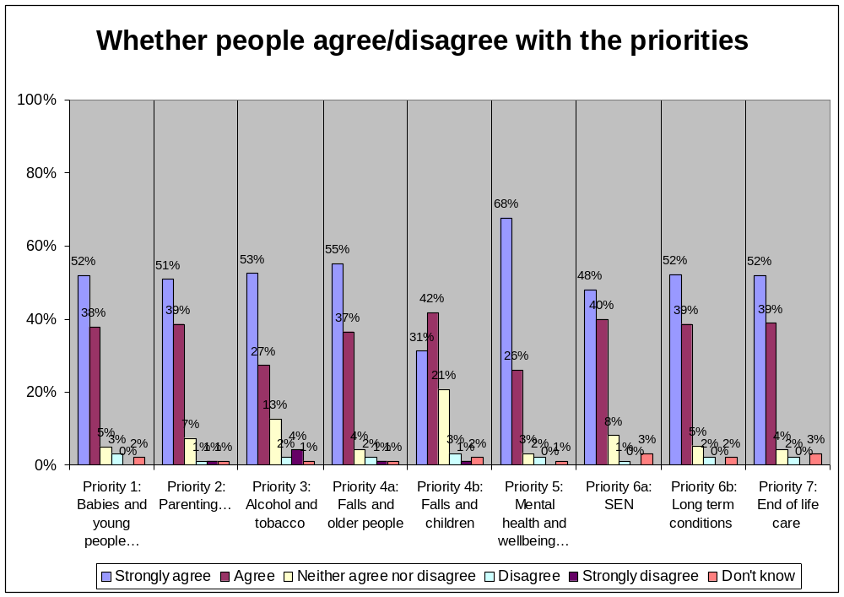
  - A majority of respondents also strongly agreed or agreed with the proposed plans (58% to 76%) and goals (68% to 87%). The least support was for the plans and goals relating to falls, accidents and injuries amongst children and young people and reducing the harm caused by alcohol and tobacco. It should be noted however that only 1% to 7% strongly disagreed or disagreed with either the plans or goals, far fewer than those who neither agreed nor disagreed with them (27% to 31% ) – suggesting that they either had no opinion or the information provided was not detailed enough for them to reach one.
  - Nearly 400 separate comments were logged, excluding comments gathered at a specially convened workshop with health, care and other professionals and at a carer’s forum. Comments were received on each of the priority areas and other comments respondents wished to make. The latter fell into three broad themes - what they felt was missing, delivering the priorities and the evidence base.
  - An initial Equalities Impact Assessment carried out on the consultation document, and feedback from a specially convened Inclusion Advisory Group meeting, concluded that whilst the vision included reducing inequalities the proposals provided insufficient detail about the areas and population groups that experienced inequalities or how the strategy would address these and measure progress towards reducing them.
  - Section 7 below sets out recommendations to the Health and Wellbeing Board in light of the feedback received, the outcomes of the initial Equalities Impact assessment, and a review of the evidence and in keeping with the original planning principles that the Board agreed at the outset of the strategy development process. In summary the Board were recommended to:
- Retain all the proposed priorities but amend the priority relating to alcohol and tobacco to a broader ‘healthy lives, healthier lifestyles’ priority which, in addition to alcohol and tobacco has an additional focus on obesity and physical inactivity and acknowledges the importance of existing drug misuse and sexual health programmes;
- Give more detail on plans and goals within the strategy and include clear outcomes, actions and targets within the action plan;
- In addition to the already agreed ‘whole life’ and ‘integrated, whole system’ approach, include the following as key approaches to delivering the vision: reducing inequalities; prevention and early intervention; joining up with services beyond health and wellbeing; and building on individual and community strengths and include actions and targets related to these, where appropriate, in the strategy and action plan; and
- Set out more clearly, where data is available, the areas and population groups that are experiencing the worst health and wellbeing currently and further strengthen the link between the Joint Strategic Needs Assessment and Health and Wellbeing Strategy.

WHY WE CONSULTED
  - The East Sussex Health and Wellbeing Board members are committed to working with people, organisations and partnerships in East Sussex to make decisions about health and wellbeing more inclusive and to make sure our efforts are joined up.
  - That’s why it was important to hear from the widest possible range of people and organisations – residents, patients, service users and carers; public, private and voluntary and community sector organisations that commission or deliver services; and other partnership boards – about whether the Board had chosen the best areas to concentrate their efforts on over the next three years.
  - Following the consultation and an analysis of the responses submitted a draft strategy will be produced in November 2012 for further comment, with a final strategy and action plan published in December 2012.

WHO WE CONSULTED AND HOW
  - The consultation was open to anyone in East Sussex and took place for 12 weeks from 22 June 2012 to 14 September 2012. A consultation document, supporting information and survey was produced and made available via the East Sussex County Council website consultation pages. The introductory web page relating to the Health and Wellbeing Strategy consultation attracted 1,288 unique page views – the second highest rate to any consultation page during the period 1st January 2012 to 16th September 2012.
  - The consultation was promoted widely via a variety of media including direct mail (email and post); newsletters; meetings and events; local press; posters and handouts at key venues including libraries, children’s centres, chemists, hospitals and GP surgeries; websites and social media (twitter and Facebook).
  - Numerous individuals, organisations and partnerships helped to promote the consultation via their own networks and this was invaluable in spreading the word and encouraging people and organisations to respond.
  - The consultation period also included:
- Presenting to representatives of 88 different organisations attending scheduled commissioning, partnership and network meetings and noting their comments;
- Promoting the consultation and logging views and comments at three Children’s Centre summer play schemes and an annual carers forum;
- Gathering views on delivering the strategy and tackling inequalities at a consultation workshop with 40 health, care and public health commissioners; key health and care providers; district and borough council representatives; police and probation service officers; representatives of the Voluntary and Community Sector; representatives of the Local Involvement Network (as the local Healthwatch is still being established); countywide partnership coordinators covering the wider determinants of health and wellbeing such as transport, skills, economic development, environment, housing and community safety; and equalities officers;
- An initial Equalities Impact Assessment and an Inclusion Advisory Group meeting with professionals and community representatives to consider equalities and access issues; and
- Updating the evidence base where more recent data had become available during the consultation period e.g. Census 2011 data.

WHO RESPONDED
  - A total of 100 surveys and 23 other written responses to the consultation document were received. Of these, 86 (70%) were from individuals and 37 (30%) from organisations. In addition, over 250 other individuals attending various meetings and events during the consultation period were informed of the strategy and any comments they made were logged and have been taken into account as part of the consultation.
  - 60 people filled in the consultation survey as an individual (member of the public, patient or client, carer or other) and were asked the ‘about you’ questions. Of those:
- Between 78% and 92% answered specific ‘about you’ questions e.g. age, gender;
- 62% (37) were members of the public; 18% (11) were patients or service users; 15% (9) were carers; and 5% (3) were ‘other’;
- 25% (14) were male; 75% (41). 51 people answered the question on transgender, with 92% (47) saying they didn’t identify as transgender and 8% (4) choosing ‘prefer not to say’;
- Responses were received from every age group, the lowest being 18-24 year olds (4% (2)), the highest being 55 to 64 (30% (16));
- 87% of respondents were white British or white other; 6% were Black British Caribbean or British African; 7% preferred not to say;
- 23% (13) considered themselves to have a disability. Of these 6 have a physical impairment; 5 have a long-standing illness or health condition; 3 have a mental health condition; and one a learning disability;
- Of the 44% (22) who consider themselves to have a religion or belief all are Christian; and
- 56% (30) consider themselves to be heterosexual; 23% (12) consider themselves to be lesbian, gay or bisexual; 4% (2) stated other; and 17% (9) preferred not to say.
  - 60% (36 individuals) provided postcodes. The map below showing the distribution of these respondents indicates that the majority live in or near our coastal towns.

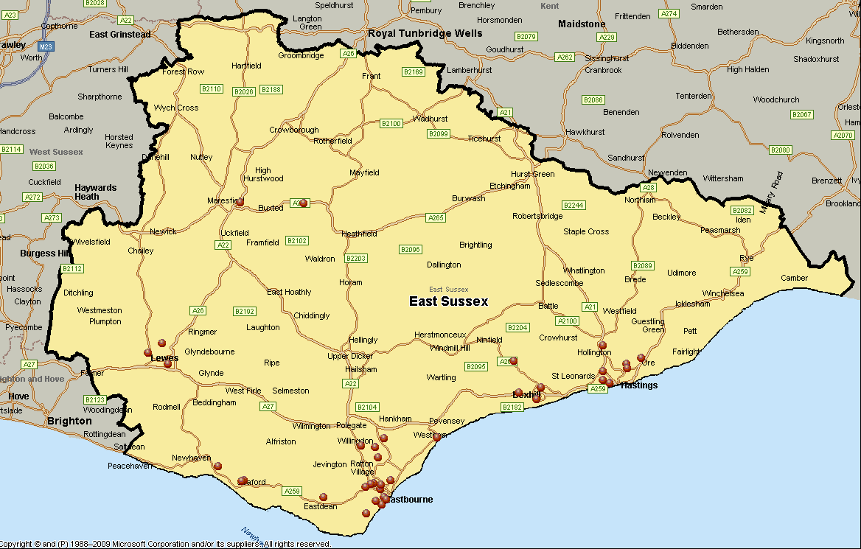
  - The 37 organisations and partnerships that submitted responses are listed at Appendix A and include local, district and borough, sub-county and countywide organisations from the public and voluntary and community sectors. Note that at the start of this first phase of consultation the opportunity to comment on a draft strategy and action plan in October was offered. There may be organisations that have not responded at this stage but will do so once the draft strategy and action plan is published.

WHAT RESPONDENTS TOLD US
  - Nearly 400 separate comments were logged via surveys, written responses, meetings and events, excluding comments noted at the consultation workshop with health, care and other professionals. These provide views on each of the proposed priorities and other issues respondents felt were missing or should be given a higher profile within the strategy. These are summarised below. Reference below to ‘residents’ covers responses from members of the public, patients, services users, carers and elected members. ‘Other’ covers responses from professionals, organisations and partnerships.
  - The priorities – general comments: 7 comments were received supporting the priorities and general direction that the Board proposed to take, noting in particular the whole life approach; that priorities were based on evidence and therefore focused on greatest need; and complementing and adding to what is already taking place.
  - Priority 1: The best possible start for all babies and young people
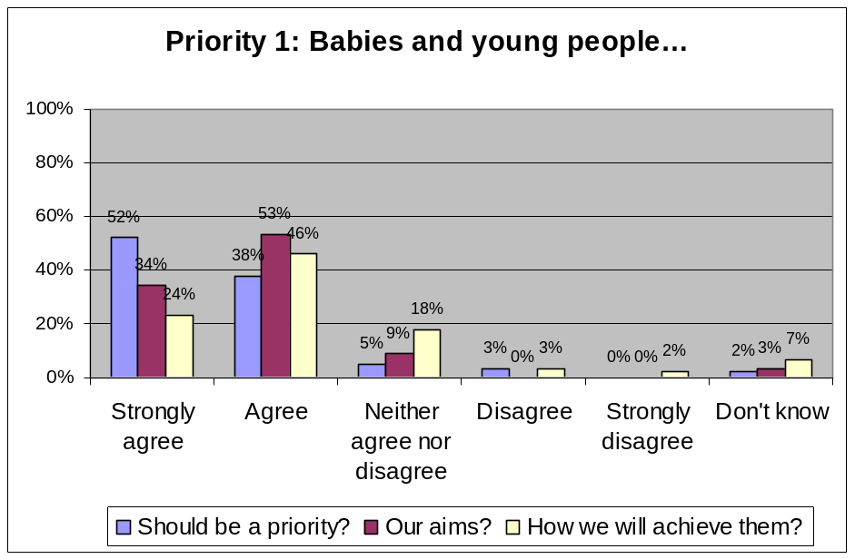
- 90% of survey respondents ‘strongly agreed’ or ‘agreed’ with the priority; 3% ‘disagreed’. 5% strongly disagreed or disagreed with the plans but none disagreed with the goals. 18% neither agreed nor disagreed with the plans and 9% neither agreed nor disagreed with the goals.
- In total, 24 comments were received on this priority. Of those who disagreed with the priority, plans or goals - residents’ concerns were that resources should be targeted at groups they felt were in greater need e.g. people with disabilities. Others were concerned with a lack of reference to housing and housing support. Other comments from residents included wanting greater access to and more consistent parenting support for the first and subsequent children; and the need for practical goals. Others noted the importance of emotional, social and personal development, language and communication; and the impact of child poverty on early years.
  - Priority 2: Safe, resilient, secure parenting for children and young people
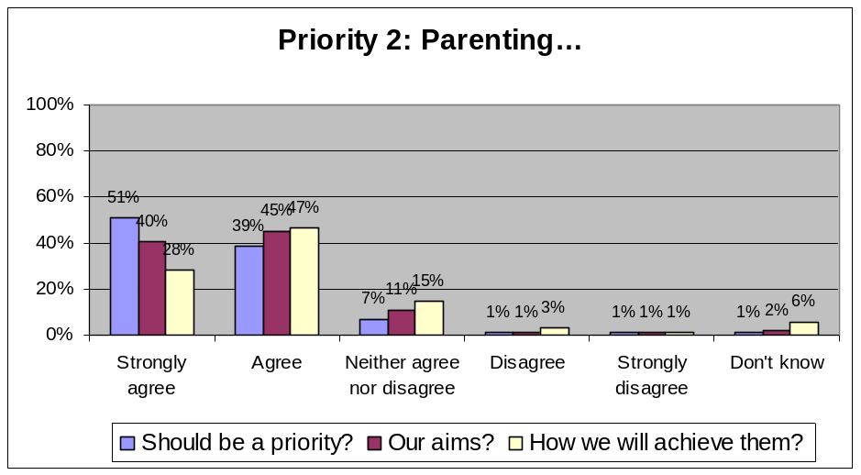
- 90% of survey respondents ‘strongly agreed’ or ‘agreed’ with the priority; 2% ‘strongly disagreed’ or ‘disagreed’. 4% strongly disagreed or disagreed with the plans and 2% disagreed with the goals. 15% neither agreed nor disagreed with the plans and 12% neither agreed nor disagreed with the goals.
- In total, 15 comments were received on this priority. Of those who disagreed with the priority, plans or goals - residents’ concerns were that resources should be targeted at groups they felt were in greater need. Others were concerned with a lack of reference to housing and housing support. Other comments from residents included issues around access to information and support. Others commented that the goals were outputs and should be ‘outcomes’; and links to initiatives that support families with multiple problems or challenges should be made.
  - Priority 3: Reducing the harm caused by alcohol and tobacco
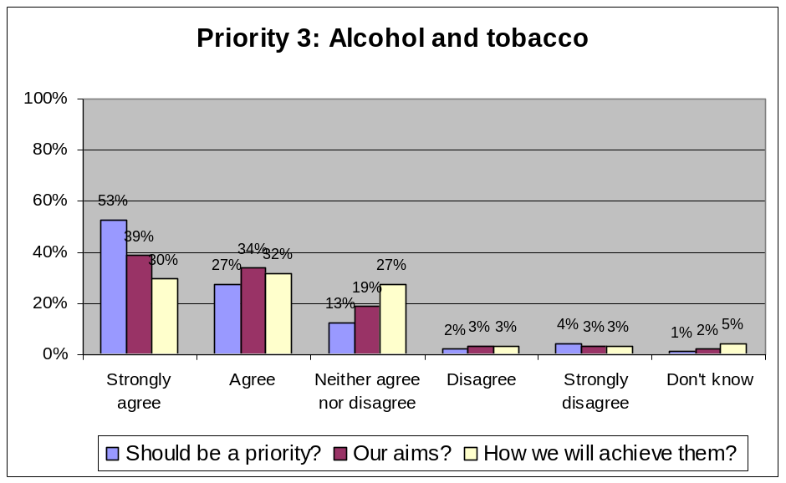
- 80% of survey respondents ‘strongly agreed’ or ‘agreed’ with the priority; 6% ‘strongly disagreed’ or ‘disagreed’. 6% strongly disagreed or disagreed with the plans and 6% disagreed with the goals. 19% neither agreed nor disagreed with the plans and 27% neither agreed nor disagreed with the goals – the second highest rate of all priorities.
- In total, 30 comments were received on this priority.
- Of those who disagreed with the priority, plans or goals - the general view amongst residents and others was that people already know the risks of drinking and smoking, there are national campaigns and local money should not be spent trying to change behaviour.
- Other comments from residents contradicted this view to a degree noting the importance of raising awareness; access to information and support; involving schools. Others commented on making the connection with long term conditions, community safety (alcohol related crime) and deprivation; access to support for smokers and drinkers; and the need to include other ‘lifestyle’ issues notably obesity/physical inactivity and drug misuse.
  - Priority 4: Preventing and reducing falls, accidents and injuries
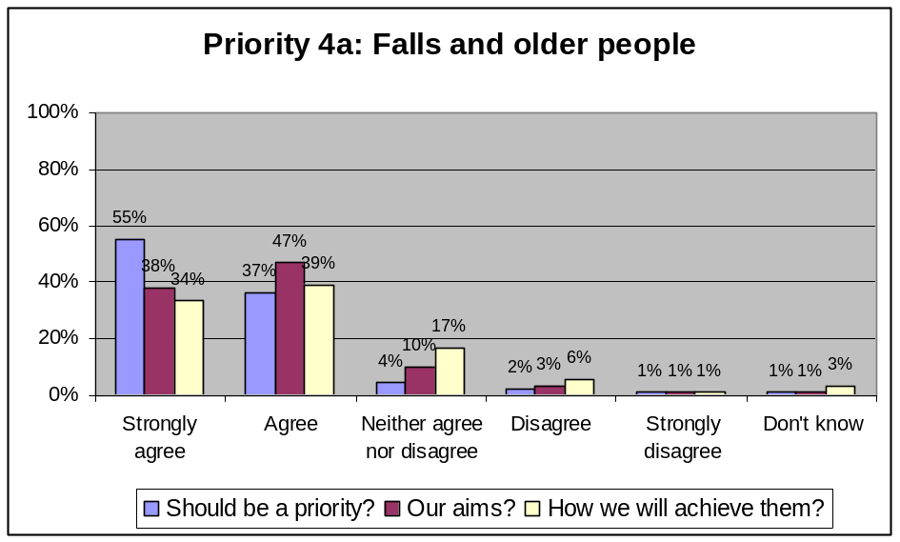
- 92% of survey respondents ‘strongly agreed’ or ‘agreed’ with the focus on older people; 3% ‘strongly disagreed’ or ‘disagreed’. 7% strongly disagreed or disagreed with the plans and 4% disagreed with the goals. However 17% neither agreed nor disagreed with the plans and 10% neither agreed nor disagreed with the goals.
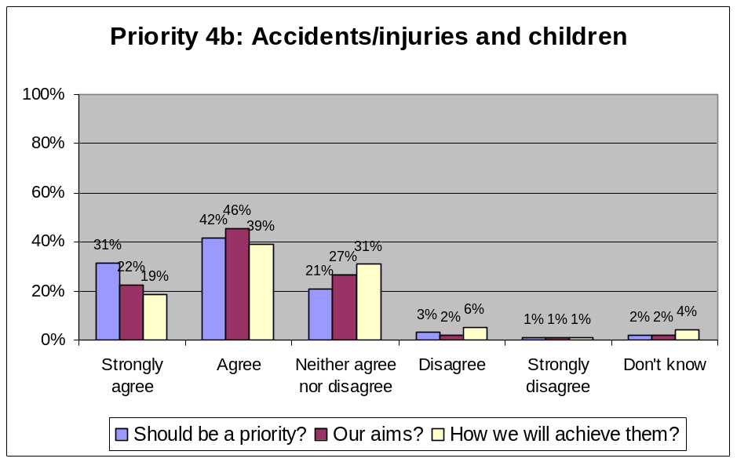
- 73% of survey respondents ‘strongly agreed’ or ‘agreed’ with the focus on children and young people; 3% ‘strongly disagreed’ or ‘disagreed’. However, when votes from parents and young people at three summer play schemes are included agreement with the priority rises to 82% indicating that this is an important priority for parents and young people. 7% strongly disagreed or disagreed with the plans and 3% disagreed with the goals. However 33% neither agreed nor disagreed with the plans and 27% neither agreed nor disagreed with the goals the highest rate for all priorities.
- In total, 38 comments were received on this priority. Of those who disagreed with the priority, plans or goals for older people - residents’ main concerns were the need for prevention; lack of links to alcohol consumption; coping with demand; and whether services could be integrated. Others highlighted the role of housing. Other comments included the need to focus on prevention; the role of physical activity/fitness in reducing the risk of falls; multiple risks requiring multi-agency responses; and better data/data sharing.
- Of those who disagreed with the priority, plans or goals for children and younger people - the general view was that preventing and reducing falls, accidents and injuries was a parental responsibility and that accidents happen and are part of growing up. Other comments from residents included offering parents more advice, information and training in dealing with minor injuries to reduce GP or A&E attendances; teaching children how to play safely; listening to concerned neighbours. Others were concerned with having a better understanding of the causes of accidents and injuries; and that multiple risks require multi-agency responses.
  - Priority 5: Enabling people to manage and maintain their mental health and wellbeing
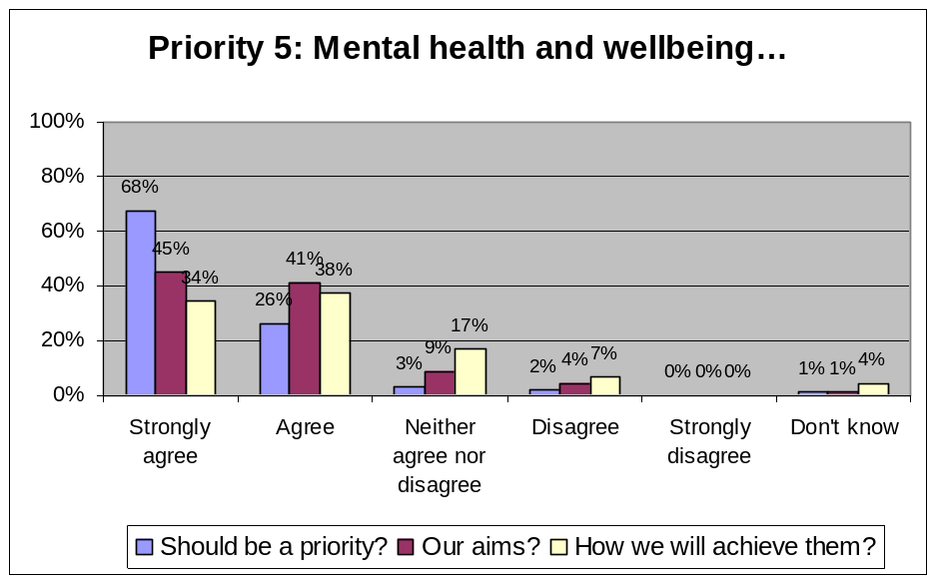
- 94% of survey respondents ‘strongly agreed’ or ‘agreed’ with the priority; 2% ‘disagreed’. 7% disagreed with the plans and 4% disagreed with the goals. 17% neither agreed nor disagreed with the plans and 9% neither agreed nor disagreed with the goals.
- In total, 36 comments were received on this priority. Of those who disagreed with the priority, plans or goals - residents’ concerns included delays in treatment leading to problems getting more severe; the role of parents; and regular health checks to identify/manage issues better. Others were concerned with a lack of reference to the impact of welfare reforms; the need for prevention; and lack of reference to dementia.
- Other comments from residents included giving a greater focus to lower level mental health concerns; more prevention and early intervention; the lack of support, understanding and activities; the need to reduce stigma; the need for a personalised approach. Others made the link between mental health and other issues such as employment, housing, social isolation and lifestyle factors such as alcohol misuse.
  - Priority 6: Supporting those with special educational needs (SEN), disabilities and long term conditions
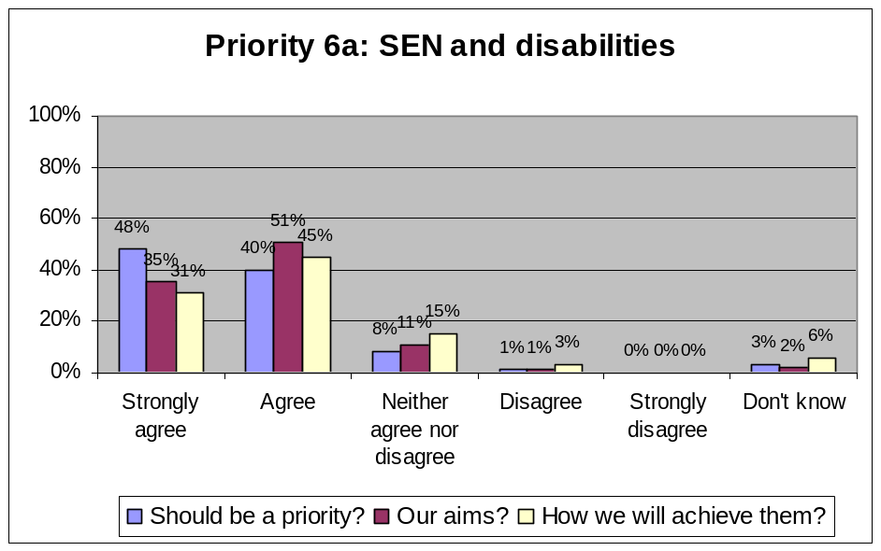
- 88% of survey respondents ‘strongly agreed’ or ‘agreed’ with the focus on SEN and disabilities; 1% ‘disagreed’. Only 3% disagreed with the plans and 1% disagreed with the goals. 15% neither agreed nor disagreed with the plans and 11% neither agreed nor disagreed with the goals.
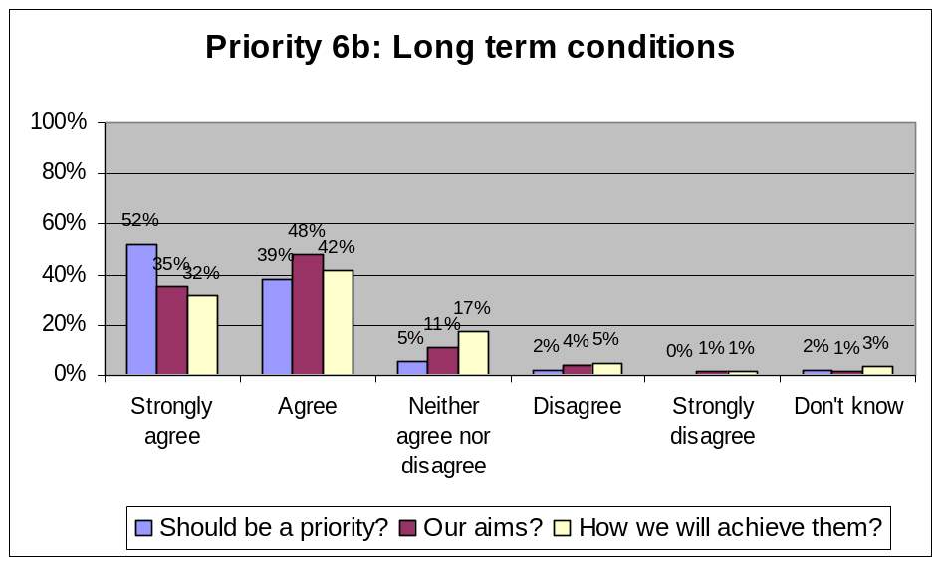
- 91% of survey respondents ‘strongly agreed’ or ‘agreed’ with the focus on long term conditions; 2% ‘disagreed’. 6% disagreed with the plans and 5% disagreed with the goals. 17% neither agreed nor disagreed with the plans and 11% neither agreed nor disagreed with the goals.
- In total, 22 comments were received on the SEN and disabilities priority focus, and 16 on the long term conditions priority focus. Of those who disagreed with the priority, plans or goals for special educational needs and disabilities - residents’ concerns included the fear of cost-cutting and wanting more cultural offers. Others commented on a lack of reference to older carers and housing. Other comments from residents included support for parent carers and parents; giving people with disabilities greater choice, control, independence and empowerment; taking a more holistic view; transitions to adulthood; joined up support for those with less severe needs or disabilities. Others noted the need for supported employment opportunities; support for parents; and a bigger focus on autism.
- Of those who disagreed with the priority, plans or goals for long term conditions - residents’ concerns included a lack of focus on prevention and lack of links to lifestyle issues such as alcohol misuse, smoking and obesity; the need for cultural offers and fears of cost-cutting. Others noted lack of links to prevention, housing and housing support and whether the plans are achievable in difficult economic times. Other comments from residents included the lack of joined up care between hospital and home; more therapeutic and social provision for those with dementia. Others made links to housing and housing support and culture; queried the absence of HIV/AIDS and suggested including a list of long term conditions that would be covered in the priority.
  - Priority 7: High quality and choice of end of life care
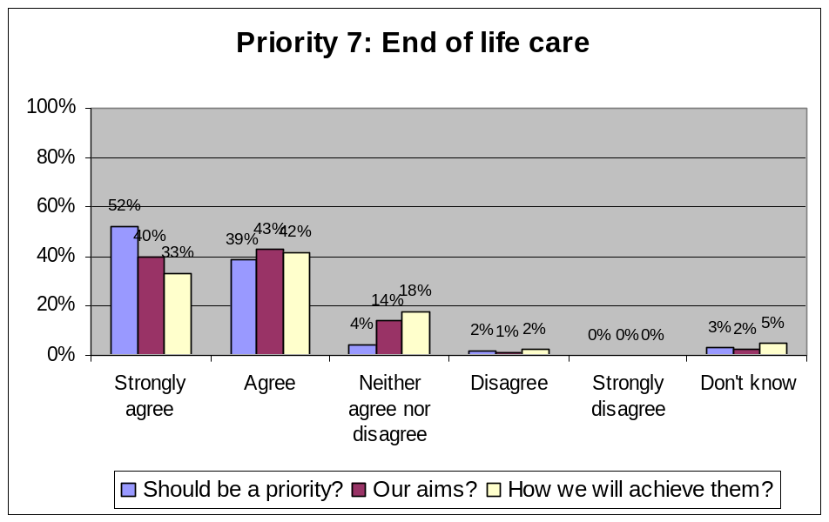
- 91% of survey respondents ‘strongly agreed’ or ‘agreed’ with the priority; 2% ‘disagreed’. 6% disagreed with the plans and 5% disagreed with the goals. 18% neither agreed nor disagreed with the plans and 14% neither agreed nor disagreed with the goals.
- In total, 13 comments were received on this priority. Of those who disagreed with the priority, plans or goals - both from organisations - one was concerned with a lack of reference to housing and the other felt that including end of life care was inappropriate as the strategy was about promoting positive health and wellbeing. Other comments from residents included the importance of bereavement support; hospices; workforce development to ensure quality of support. Others noted the lack of reference to hospices; the importance of workforce development; better information on pain management and support for the individual, their family and carers; recognition of specific needs e.g. those in uncomfortable or unsuitable conditions; and culturally appropriate care.
  - Other comments received (listed by volume of comments received)
- Delivery: Although the consultation document stated that an action plan would be developed in light of feedback received 30 comments were received on delivery related topics notable the action plan, approaches, targets and finances and/or affordability. 15 of the 30 comments received from residents and others expressed disappointment that proposals on how the priorities and aims would be delivered were insufficiently clear. 6 expressed concerns that the cost of delivering the strategy was not included or that delivering the stated ambitions was unaffordable in the current economic climate (similar fears about cost-cutting were expressed in some priority areas). Numerous comments within each priority area mentioned the need for greater prevention and support to people (parents and people with disabilities in particular) to help build their confidence and take more control of the issues they were facing. What ‘joined up’ and ‘integrated’ meant in practice was questioned. The need to understand who the strategy was aimed at along with targeted interventions was also noted.
In addition, ‘action planning’ was a focus of a specially convened workshop with health, care and other professionals from the public and voluntary and community sector who are involved in commissioning and delivering services. Numerous comments and ideas were put forward on what success would look like (outcomes), the actions required to deliver that success; and how success would be measured (targets) as well as links between the seven priorities and to other existing strategies and plans. These contributions will help to provide more detail to the very high level plans and goals set out in the consultation document.
- Links to wider services: 28 comments were received, predominantly from professionals, organisations and partnerships, requesting that a stronger recognition of and higher profile be given to a range of issues and services that can impact on the health and wellbeing of individuals and communities predominantly housing and housing support, but also community safety, the environment, transport, community development and culture. These issues were also noted within comments linked directly to specific priorities.
- Lifestyle related issues: The lack of obesity and related concerns regarding physical inactivity and healthy eating received 25 comments - the highest volume of comments on any single health issue outside of comments linked directly to the seven proposed priorities. This concern was expressed both by residents and others. The general view was that obesity and physical inactivity in particular were issues in parts of the county; data indicates that obesity is becoming more common; and action should be taken now to prevent and reduce obesity and obesity related health conditions such as type 2 diabetes, cancer, heart disease, and liver disease increasing in the future. There were also 11 comments on the absence of drug misuse, predominantly from professionals and organisations, given the impact it has on other proposed priorities notably parenting and mental health. The argument was that whilst addressing drug misuse might not be a priority for new or different action, it must be a priority for investment or the current positive trends and savings could be reversed. 3 comments highlighted the absence sexual health, teenage pregnancy and HIV/AIDs.
- Reducing inequalities and improving access: 18 comments, 5 from residents, were received regarding inequalities and access to information, advice and support (the latter also being a common concern expressed by residents on many of the priorities). Concerns expressed by residents included poor health in Hastings; the need for equal standards of care for all across the county; and better care in the home. Others expressed similar concerns although one felt that whilst services should be made available, additional resources should not be focused on minority needs given the pressure on finances; that those with multiple issues e.g. age and race, or religion and sexuality, that the ‘chronically excluded’ such as Gypsies and Travellers, offenders, asylum seekers, sex workers, the very old etc. should be prioritised. Others commented that, despite investment, inequalities had not reduced significantly and a countywide strategy might fail to focus on more local areas or areas experiencing greater inequalities.
Further comments on this topic were also gathered at an Inclusion Advisory Group meeting with professionals and community representatives and a workshop with health, care and other professionals. In addition to comments on specific priorities, general concerns included insufficient attention being given to reducing barriers to accessing services; living in rural areas; multiple discrimination e.g. black immigrant mothers; and the need for a better analysis of deprivation and poverty.
In addition, ‘reducing inequalities and improving access to information, advice and support’ was a focus of a specially convened workshop with health, care and other professionals from the public and voluntary and community sector who involved in commissioning and delivering services. Numerous comments and ideas were put forward on what individuals and organisations could to better together to tackle inequalities and improve access. These contributions will help provide more detail to the high level plans and goals set out in the consultation document.
- The evidence base: 16 comments were received, predominantly from partnership meetings, regarding the data and evidence supporting the strategy (excluding references to data and evidence logged in support of comments made in the seven priority areas). Comments included making more reference to the Director of Public Health reports, the Marmot Review and other national and local reports; providing a clear explanation of how the priorities were selected (on grounds of evidence); providing more information on the people and communities the strategy is aimed at, including the impact of demographic changes (age and ethnicity); concerns about the availability of local data and links to the Joint Strategic Needs Assessment; and the need to ensure the strategy is regularly reviewed and refreshed in light of any changes to the evidence base.
- Dementia: 8 comments were received, predominantly from professionals, organisations and partnerships, questioning the low profile given to dementia given our ageing population. Evidence shows that East Sussex has the highest dementia prevalence in the UK and this is projected to rise significantly over the next decade. The concern is that services need to be developed and sustained to cope with increasing demand, and to reduce the risk of crisis hospital admissions and care’s becoming ill as a result of their caring role.
- Older people: 7 comments were received from residents and others asking why older people were not given any particular focus given our large and ageing population, two of these comments also noted the impact of social isolation on older people’s health and wellbeing.
- Carers: 7 comments were received (in addition to references within a few of the priority areas) noting that the health and wellbeing of carers and the contributions they make were mentioned in the consultation document but that carers’ health and wellbeing should be given a higher profile. In addition, at an annual carer’s forum, carers were asked what their greatest health and wellbeing concerns were and what could help to address them. 79 comments were logged including concerns about what happened to their cared for if the carer became ill or died; the need for care in the home, supported housing, supported employment and respite breaks; the benefits of healthy eating, back care and exercise in particular; and adequate funding for health and carer’s services.

EQUALITIES IMPACT ASSESSMENT (EQIA) – INITIAL RESULTS
  - The Health and Wellbeing Strategy aims to address the health and wellbeing needs of the population of East Sussex throughout all stages of their lives, but focuses on a small number of priorities where the Board feels a difference could be made over the next three years. Reducing inequalities is part of the overall vision and the assumption is that action to address inequalities would be embedded in all priorities. Overall, the strategy should therefore impact positively on all protected characteristic groups. However, for some protected characteristic groups the likelihood of a positive impact is clearer because of the focus of particular priorities notably age (children, young people and older people) and disability.
  - We know that health inequalities exist within and between different geographical areas and population groups; health inequalities often reflect inequalities in wider health determinants such as access to good housing, transport, education and employment opportunities; and health inequalities are more common in areas of poverty and deprivation. The consultation document acknowledges this but does not go into any detail regarding any particular areas or population groups that experience greater inequalities or that might be targeted for specific support to reduce those inequalities. It is therefore difficult to be sure that the proposals would have a positive impact on all protected characteristic groups.
  - The consultation document and resulting strategy is based on the most recent and most local data available to us. Local data (e.g. below national or below county) is limited or for some protected characteristic groups. In these instances, national data and research is used and extrapolated to provide a local picture. Without a clearer local picture based on local data, it may be difficult to identify the areas and population groups experiencing inequalities and which may therefore need targeted support.

HOW THE CONSULTATION AND EQIA WILL INFORM THE STRATEGY AND ACTION PLAN
  - At its meeting on 9 October, a number of recommendations were presented to the Board in light of the feedback received, the outcomes of an initial Equalities Impact Assessment; and a review of the evidence. The fundamental principles agreed by the Board at the start of the strategy development process were been applied, namely that the strategy would:
- Take a ‘whole life’ approach;
- Be based on evidence;
- Not duplicate other plans already in place; and
- Set high level messages and establish performance indicators to measure progress.
  - The Board was recommended, and agreed, to:
- Retain 6 of the 7 proposed priorities as originally proposed but amend the priority on alcohol and tobacco to a broader priority ‘encouraging people to live healthy lives and healthier lifestyles’. This priority would be seen as key to creating positive impacts on all other priorities;
- With regard to the priority for alcohol and tobacco that:
  - The priority should be amended to ‘encouraging people of all ages to live healthy lives and healthier lifestyles’. The revised priority would retain a focus on alcohol and tobacco but include a focus on obesity and physical inactivity after a review of the evidence has shown that obesity is the second highest cause of preventable death in England after smoking; across East Sussex almost ¼ of adults are obese and this rises to 27% in Hastings; and Hastings has significantly higher rates of obesity than the England and East Sussex average;
  - This revised priority should also acknowledge the need for investment in drug misuse and sexual health programmes given the link to healthier lifestyles and the positive impact ‘healthier lifestyles’ will have on other priorities including parenting, long term conditions and mental health and wellbeing. They should not however be given a specific focus as performance is good, trends are positive and there is little that the Board could do that would add value to the very successful work already taking place;
- Provide more detail on plans and goals within each of the seven priorities to address the high levels of respondents who ‘neither agree nor disagree’ or ‘don’t know’ about the proposed plans and goals;
- Reflect the issues that respondents have highlighted as important such as the links between lifestyle and mental health; the role of hospices within end of life care; and the health and wellbeing of carers:
- Older people and dementia, associated with our large and ageing population, have already been acknowledged and will be referred to in the strategy; proposed priorities include a number of issues which affect older people more than other age groups such as falls, long term conditions and end of life care; and there is already a well-established joint commissioning plan for adults in later life (Living Longer, Living Well) and joint commissioning plans for dementia which the Health and Wellbeing strategy aims to add value to;
- Include, within each priority area, a list of complimentary commissioning and partnership plans relating to the priority so that people can see what else will continue to be delivered outside of the Health and Wellbeing Strategy and which the Health and Wellbeing Strategy aims to add value to;
- In addition to the already agreed ‘whole life’ and ‘integrated, whole system’ approach, include the following as key approaches to delivering the vision: reducing inequalities; increasing prevention and early intervention; joining up health, care and wider services that impact on people’s health and wellbeing; and building on individual and community strengths and include actions and targets related to these, where appropriate, in the strategy and action plan;
- Set out more clearly, where data is available, the areas and population groups that are experiencing the worst health and wellbeing outcomes currently and which may need targeted support over and above the services that would be available to all residents within the county regardless of where they live, who they are, or their circumstances;
- Produce, as planned, an action plan setting out actions, outcomes and targets including appropriate references to reducing inequalities, prevention, and wider services. The action plan should remain high level and strategic;
- Pass on all comments received to Clinical Commissioning Groups so that they can be taken into consideration when more detailed commissioning plans, action plans and service specifications are being developed or reviewed; and
- Further strengthen the link between the Joint Strategic Needs Assessment and Health and Wellbeing Strategy.

WHAT HAPPENS NEXT
  - A draft strategy will be produced and published in November and individuals and organisations will have a further opportunity to comment. A detailed Equalities Impact Assessment on the draft strategy will be undertaken.
  - In light of any further comments received and the detailed Equalities Impact Assessment, recommendations on any further changes required will be taken to the Health and Wellbeing Board on 11 December for their consideration. Following discussion a final strategy and action plan will be agreed and published in December.

Appendix A: Organisational/Partnership responses to the consultation
- Action for Change
- Age UK East Sussex
- Broadway United Church
- Campaign for Better Transport - East Sussex
- Care for the Carers
- Chestnut Tree House
- Crime Reduction Initiatives (CRI)
- Cycle East Sussex
- Eastbourne Borough Council
- Eastbourne Ethnic Minority Society
- Eastbourne Hailsham and Seaford Clinical Commissioning Group (CCG)
- Eastbourne Seniors Forum
- East Sussex Drug and Alcohol Action Team Board
- East Sussex End of Life Care Programme Board
- East Sussex Health Overview Committee (HOSC)
- East Sussex NHS Healthcare Trust
- Friends, Families and Travellers
- Hastings Borough Council – Housing Services
- Hastings Chinese Association
- Hastings Local Strategic Partnership, Leader of Hastings Council, Lead Member for SHP and Community Services and Chair of Healthier Hastings Partnership Board (Joint response)
- Hastings and Rother Clinical Commissioning Group (CCG)
- Hastings and St Leonard’s Seniors Forum
- Hastings Voluntary Action
- High Weald Lewes and Havens Clinical Commissioning Group (CCG)
- Lewes District Council
- Newhaven Community Development Association (NCDA)
- Rother District Council
- Rother District Council – Housing Services
- Shinewater School
- South East Advocacy Project (SEAP)
- Southdown Housing
- Sports 13
- St Michael’s Hospice
- Sussex Police
- Wave Leisure Trust
- Wealden District Council
- Wealden Local Strategic Partnership

