Dawn Whittaker
Chief Executive and Chief Fire Officer of East Sussex Fire and Rescue Service

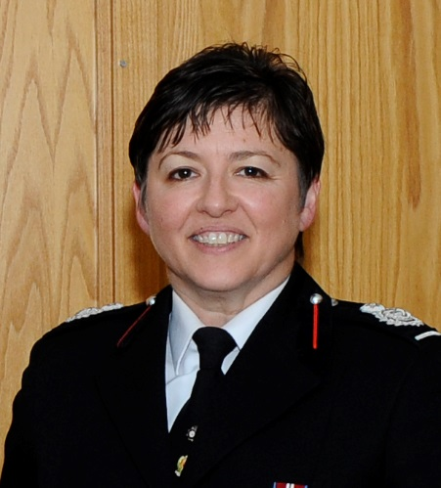

Early life and Education

Dawn was born and brought up in a rural area of South Wales, where her family still farm.
She studied Hotel, Hospitality and Tourism in Wales for four years before joining the John Lewis Partnership as a graduate trainee in 1988, she worked all over the UK in her 14 years with JLP and says they were a great company to work for as they believed in developing their staff and leaders as well as providing their customers with quality and excellent service as market leaders in department retail.

Dawn completed her Masters in Business Administration in 2013, with her dissertation focus being on new models for emergency service provision in rural areas, with a slant on rural sociology.

She completed the Cranfield Executive Director programme in 2014 and had the fascinating opportunity of developing a revised business strategy model for the Williams Formula 1 racing team as part of the programme.

Career

Dawn left JLP in 2002 and joined Northamptonshire County Council as a Performance Manager, later heading up the county council’s programme office. In 2004 she became the Assistant Director for Public Protection, overseeing the planning and performance in Fire and Rescue, Trading Standards, Coroner’s Office, Registration Services and some parts of community safety for the county.

In 2006 she moved into an operational role directly with Northants Fire and Rescue when she took up the Area Manager Planning, Performance and Finance role. She went “back to basics” and qualified operationally, progressing to Assistant Chief Fire Officer and then Deputy in 2008, her final reference was Organisational Development, Health, Safety and Wellbeing and oversight of Industrial relations. As an operational Incident commander of some fairly large incidents including Floods, Factory Fires, and a major incident on the M1 and as Gold Commander at Silverstone during the Grand Prix, she has had some interesting experiences, not least culturally as she joined the Fire Service.

In 2012 she undertook a six month secondment to Warwickshire Fire and Rescue Service to offer strategic support as their management team were in the midst of the Atherstone – on –Stour investigation.

In April 2014 she was offered an opportunity for a secondment to central government to support the Chief Fire and Rescue Adviser with some major policy work, advising civil servants and ministers provided a whole new insight as to how central government works and she enjoyed leading work on developing the Crown Fire Safety Inspection function (the regulatory function for fire safety in prisons and government buildings), she also advised on several major incidents that involved COBR including the northern floods of 2015 and also Bosley Mill and Didcot power station disasters.

Dawn joined East Sussex Fire and Rescue Service in June 2016 as Deputy Chief Fire officer and in April 2017 took up the role as Chief Fire Officer on an interim basis before being formally appointed in October 2017.

Areas of Professional Interest

Quality and People matter the most to her.
She sights her particular area of interest as Drowning Prevention (for which she is the National Fire Chief Council Lead Officer).

She considers Health, Safety and Wellbeing in the workplace as vital and in particular developing a rounded approach to Wellbeing (she is one of the champions for the MIND blue light programme).
Successful change Management has been a focus during her career, in terms of helping both people and organisations to improve planning, learning and performance.

As a senior women in the public sector, Dawn has also strived to use her experience and skill set to help support other women and is a qualified and experienced coach, mediator and mentor.

Charity work

Passionate about Charity work, Dawn has worked as a volunteer, fundraiser and also as a Trustee on the Board of several charities including Chair of the Board of Trustees for the Royal Lifesaving Society UK.

As a volunteer medical community responder for four years, she has also been able to use her experience to support her local community and attended many Red 1 and Red 2 calls, several of those have been to neighbours in the village where her family are still based in Northamptonshire

Interests and Hobbies

As well her voluntary work, she is a keen gardener and enjoys the outdoors. She is also busy renovating a house in the Pyrenees with her husband…it’s a long project, but a great place to fit in a few inexpensive days out skiing.

Family

Married to David, who is also a serving officer in another fire service, between them they have 5 children and two grandchildren. Family life is busy…though even the youngest is now in her A level year with two others in University.

